**Unlocking Insights Into The Global Air Transportation**

**Submitted by**

**Team id**

**NM2023TMID19893**

**Team members id**

**1. T.Abarna 37087B91845D47DBC80474BB9F9E9FD3**

**(TeamLeader)**

**2. S.Aarthi A05E4A2852549A4A0A04CDE1364A6FDA**

**3. S.Abi 7AAA62A0AD6B96B99934E6B72CF16C24**

**4. S.Abitha 41643E989A8A1BFAA1B4FF047A4131F9**

**5. G.Janani 5A226FDF26952F495B644B7EF386D2FA**

**6. T.Sowntharya 4EF08A350CD4B929F734C349623F7811**

**7. M.Thirisha EE1075CC1F3F1F88AED4DD4F9A457AC2**

Under the guidance of

**Dr. K. Lilly Mary Eucharista Assistant Professor**

**Department of Physics**

**Sri Meenakshi Government Arts College for Women (A)**

**Madurai – 625 002**



**October 2023**

*Unlocking Insights Into The Global Air Transportation*



# *1.INTRODUCTION*

# 1.1 Overview

The air transport system generally includes airports, Air traffic control and airlines.

Air transport networks are complex networks that span across multiple distance scales and multiple together over 5000 airline operators and has strong interdependencies with socioeconomic drivers.

The global air transportation network dataset is a comprehensive collection of information on airports, airlines and their routes.

It contains information such as names cities, countries, codes, longitudes, and altitudes of the airports across the world detailed time zone and day light saving time data.

# 1.2 purpose

### USE:

It is used for various purposes such as business and leisure travel, the delivery of time sensitive goods and emergency response and resume missions.

### ACHEIVEMENTS BY USING THIS:

Air transport generates a total of 13.5 million jobs of these 5 million are direct jobs.

# *2.PROBLEM DEFINITION AND DESIGN THINKING*

## 2.1. Empathy Map

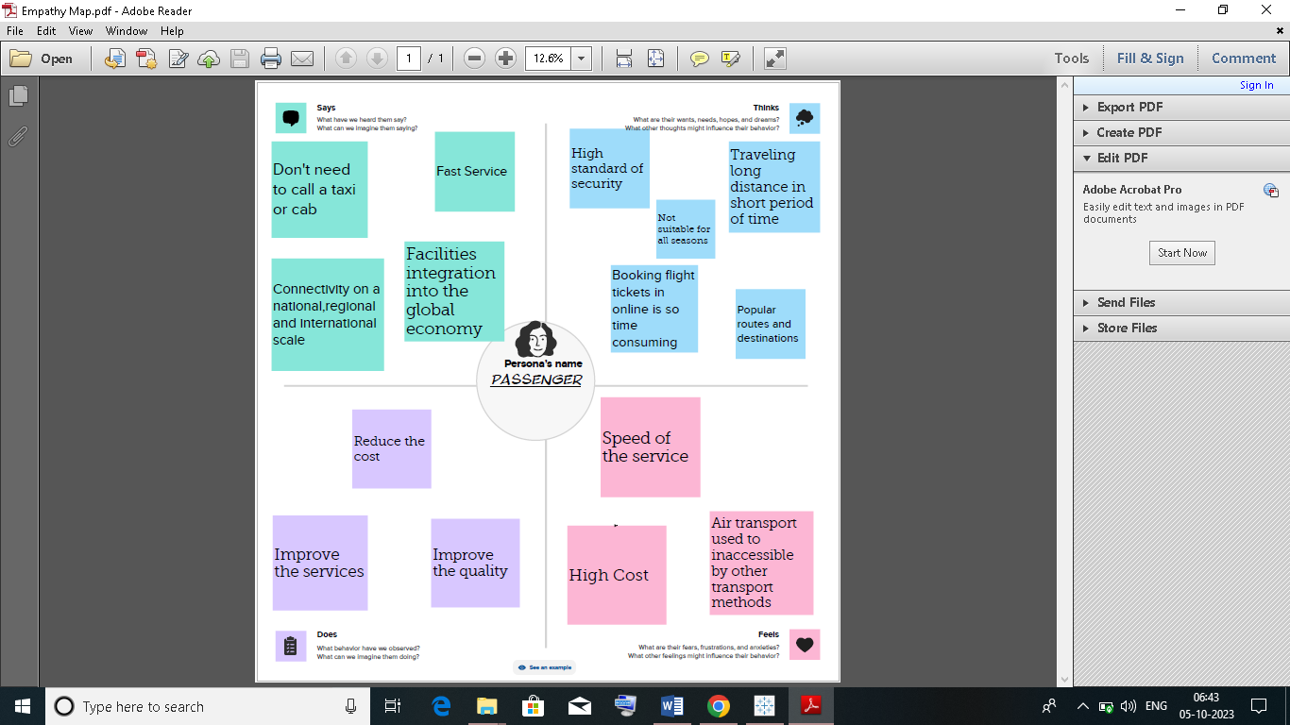

## 2.2. Ideation & Brainstorming Map

## 

## 

## 

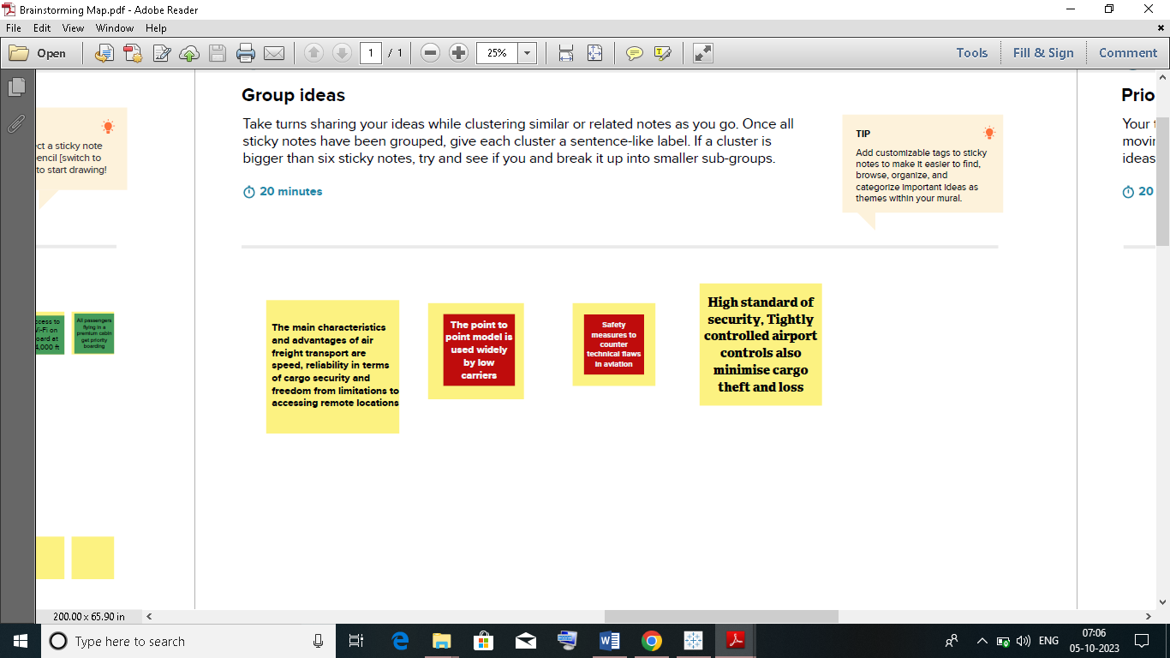

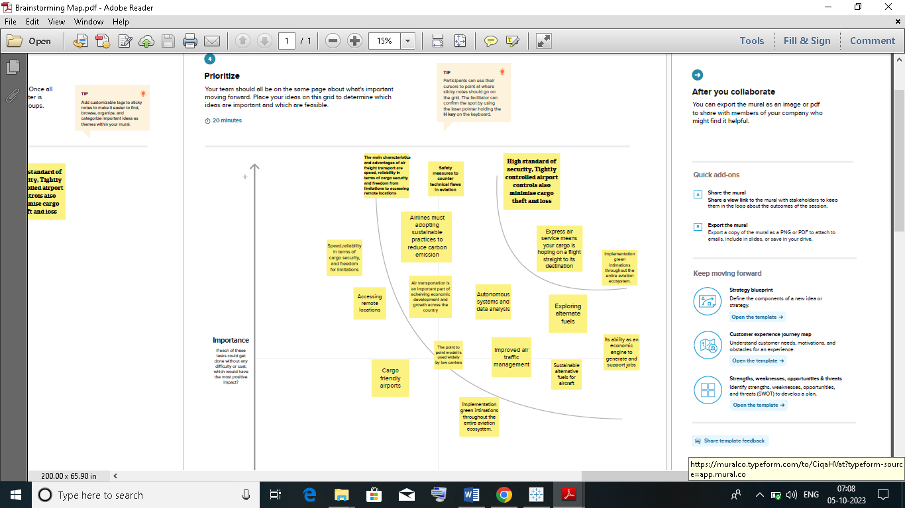

# *3.RESULT*

#### Airports within the country

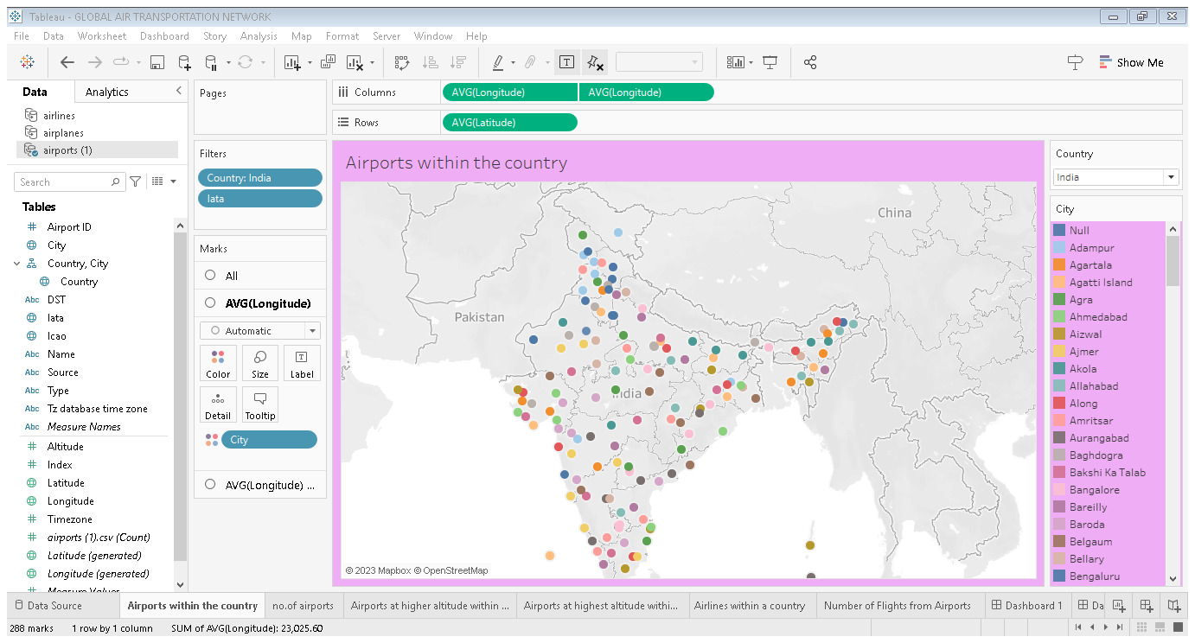

#### Number of airports

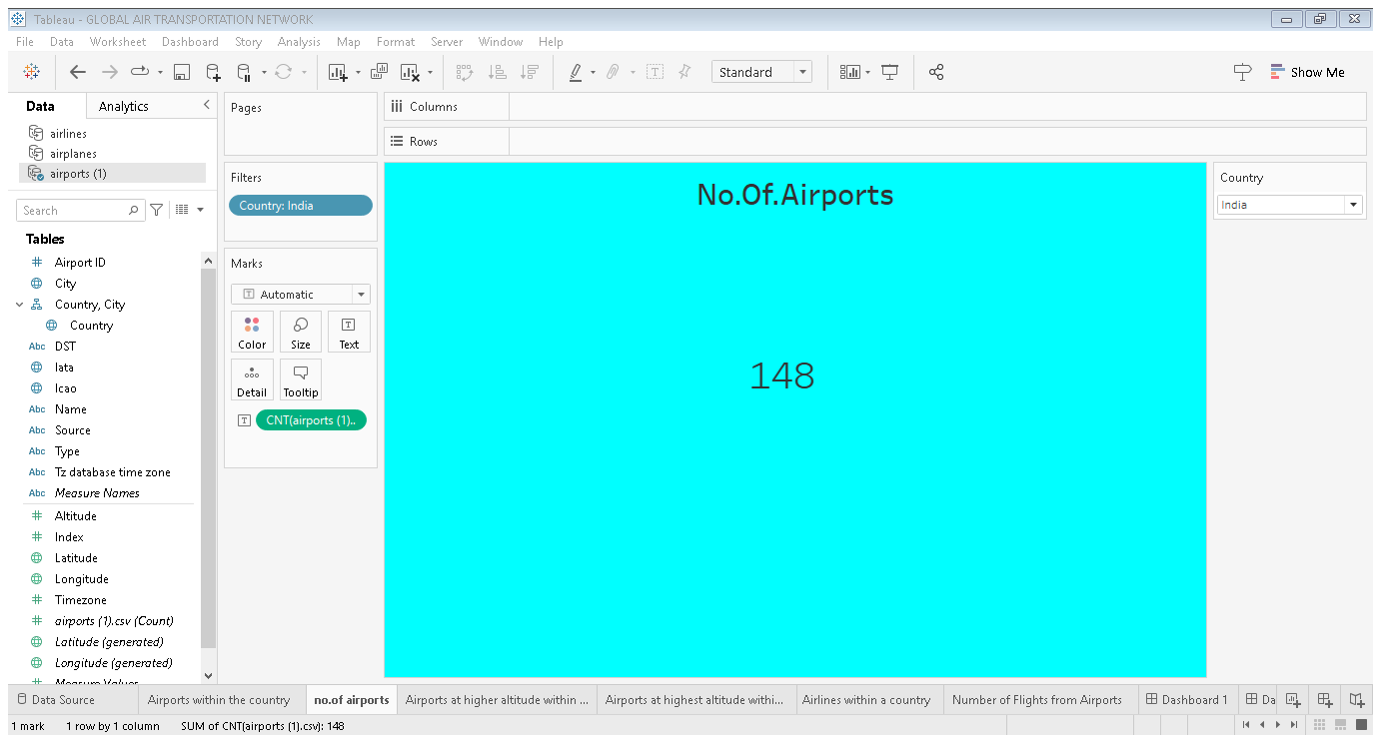

#### Airports at higher altitude within a country

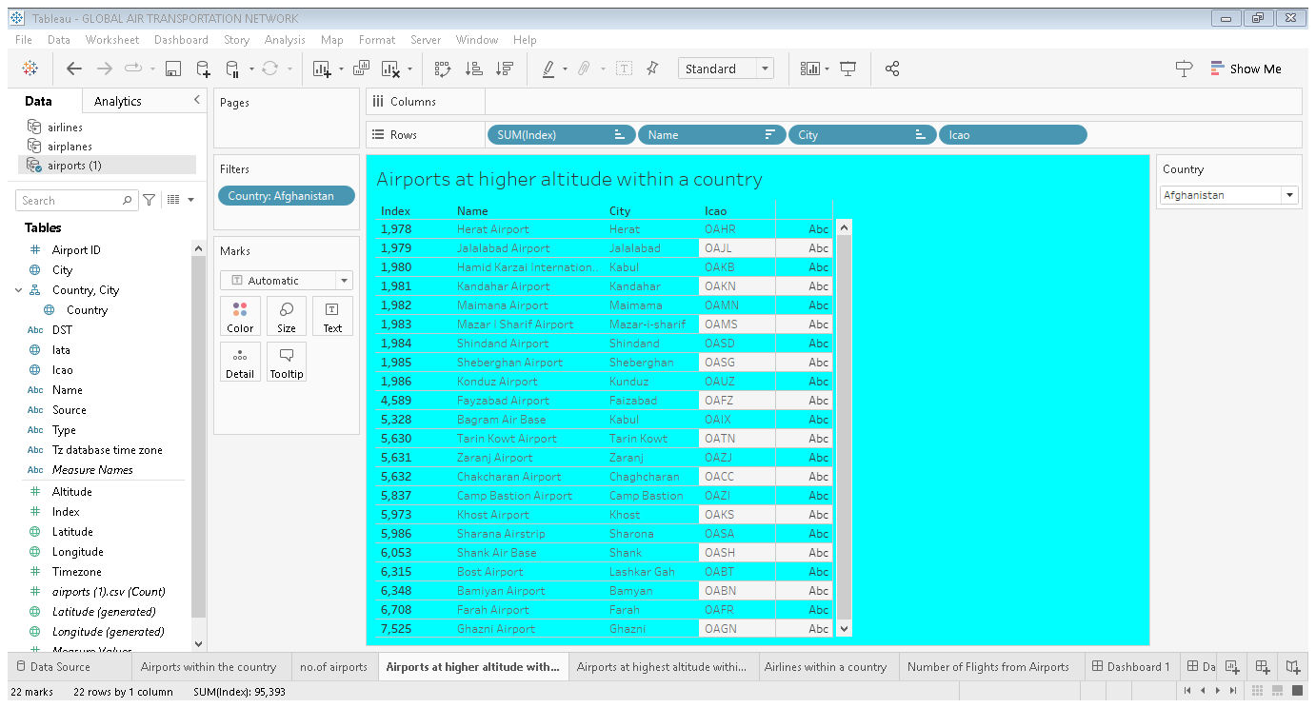

#### Airports at highest altitude within a world

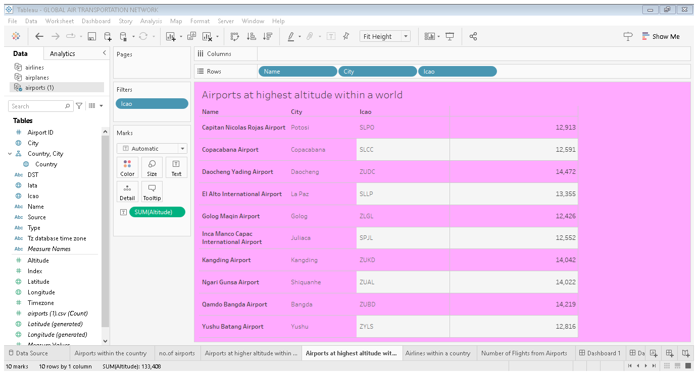

#### Airlines within a country

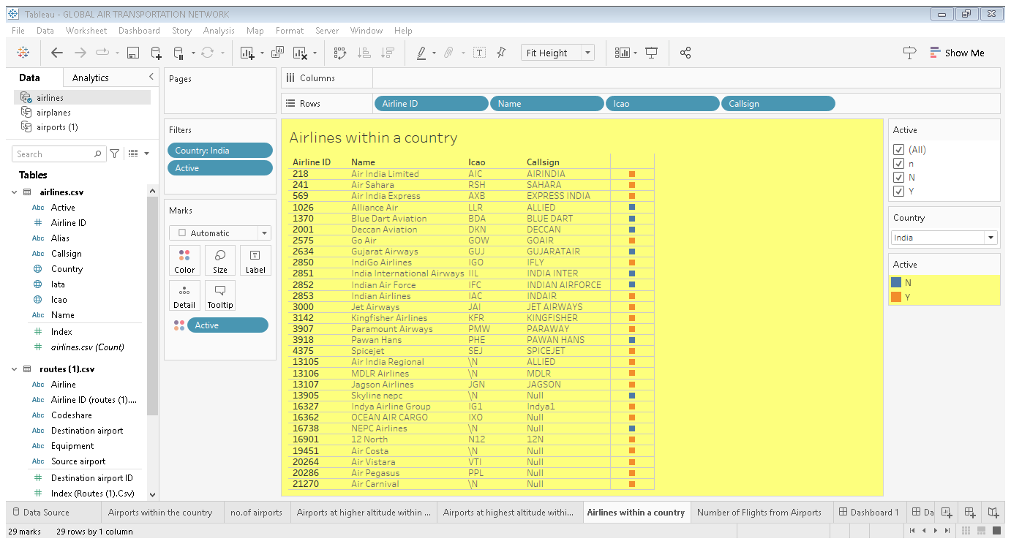

#### Number of flights from airports

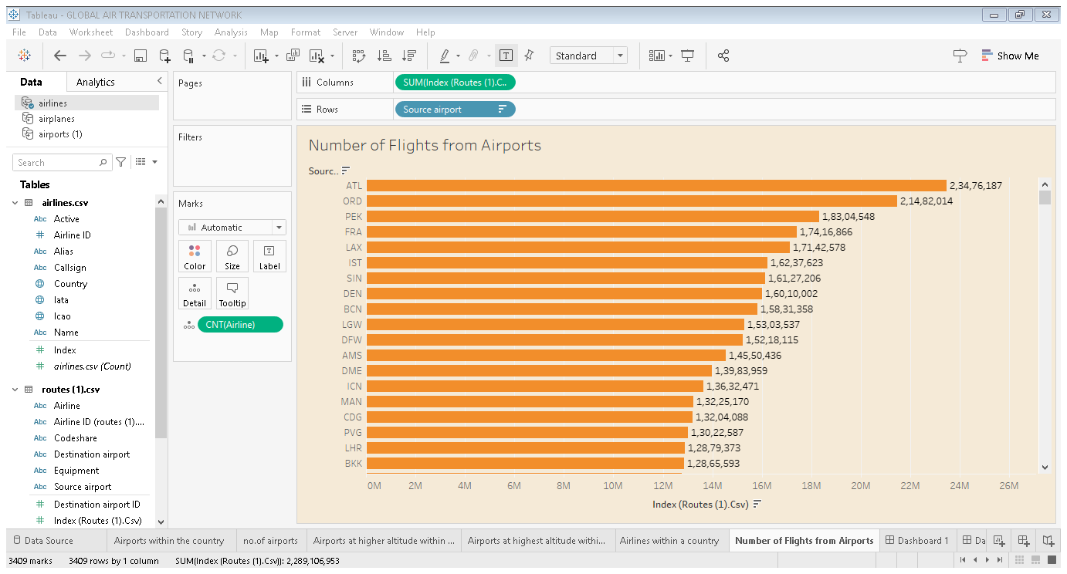

#### Country with maximum number of airports

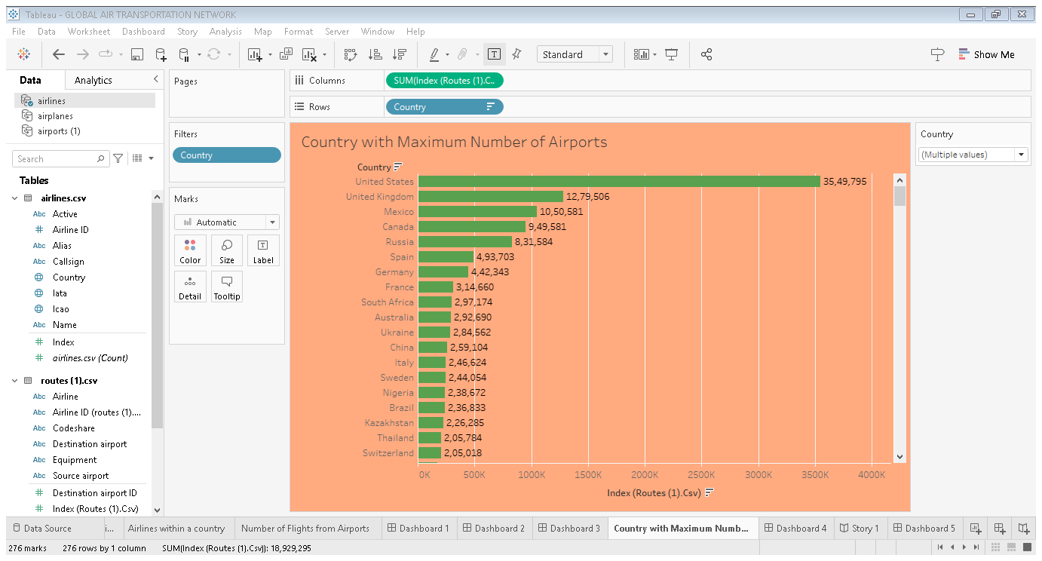

#### Dashboard 1

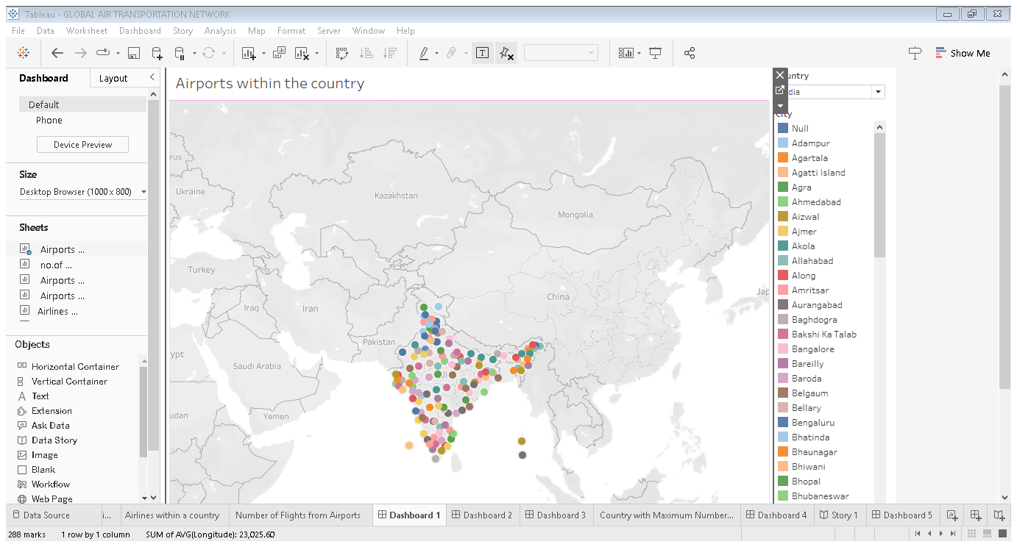

#### Dashboard 2

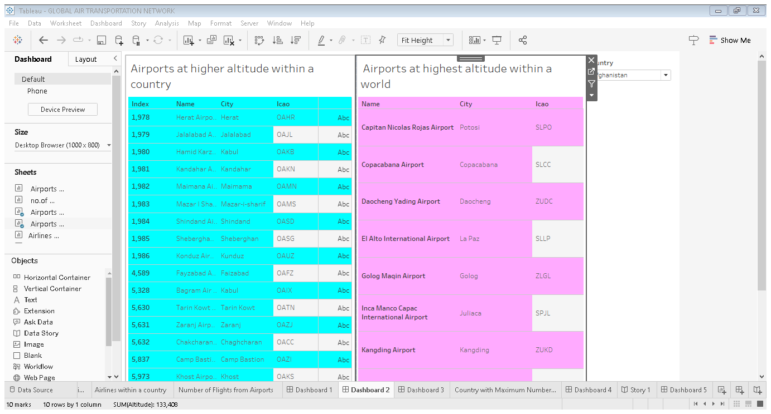

#### Dashboard 3

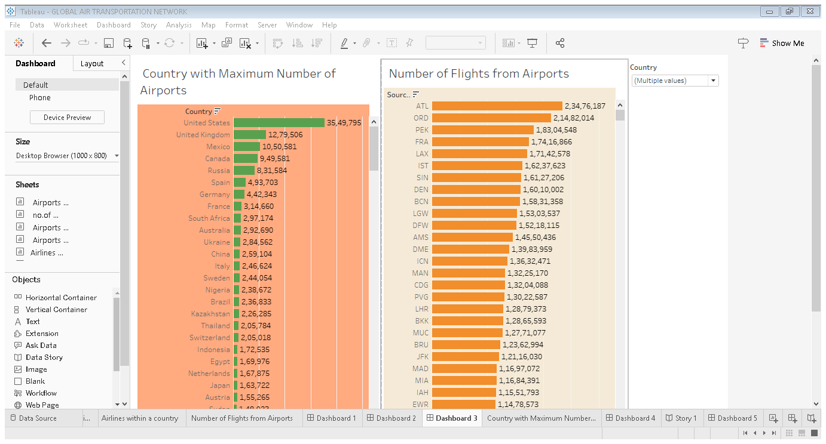

#### Dashboard 4

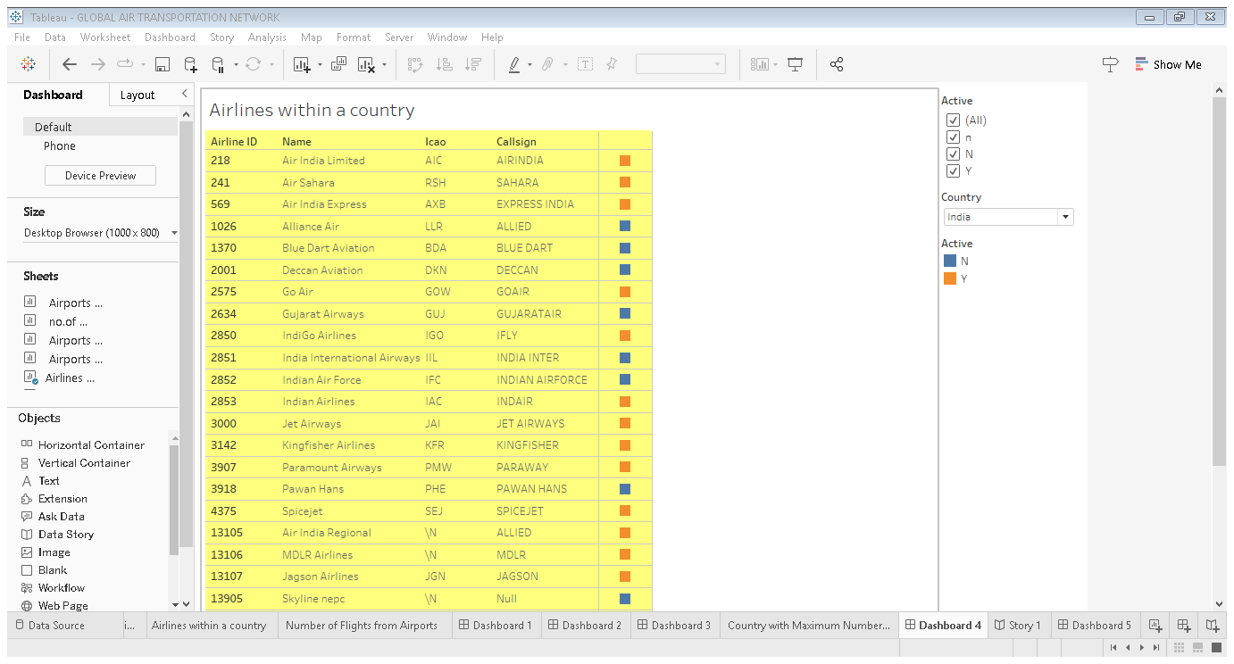

#### Dashboard 5

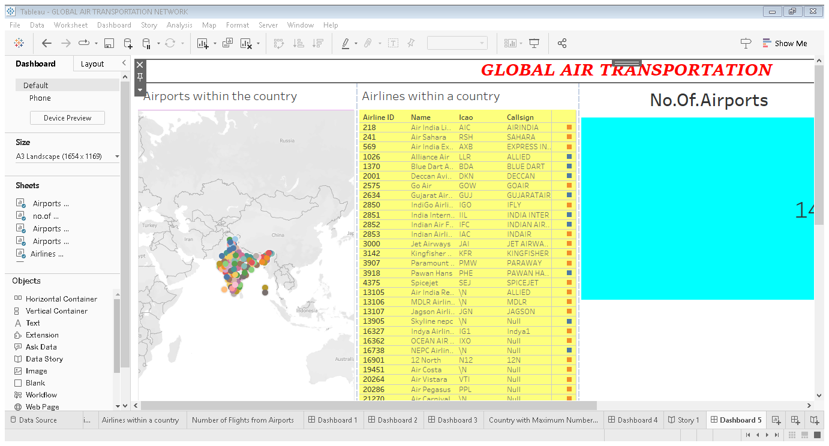

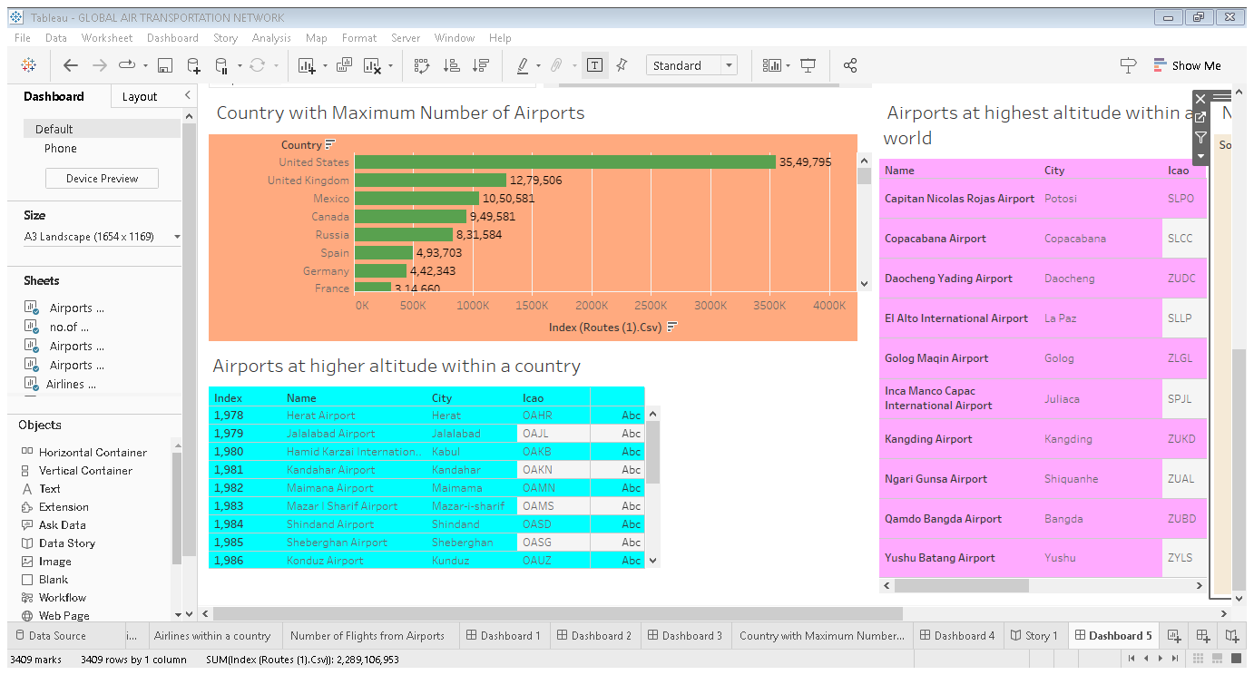

#### Story

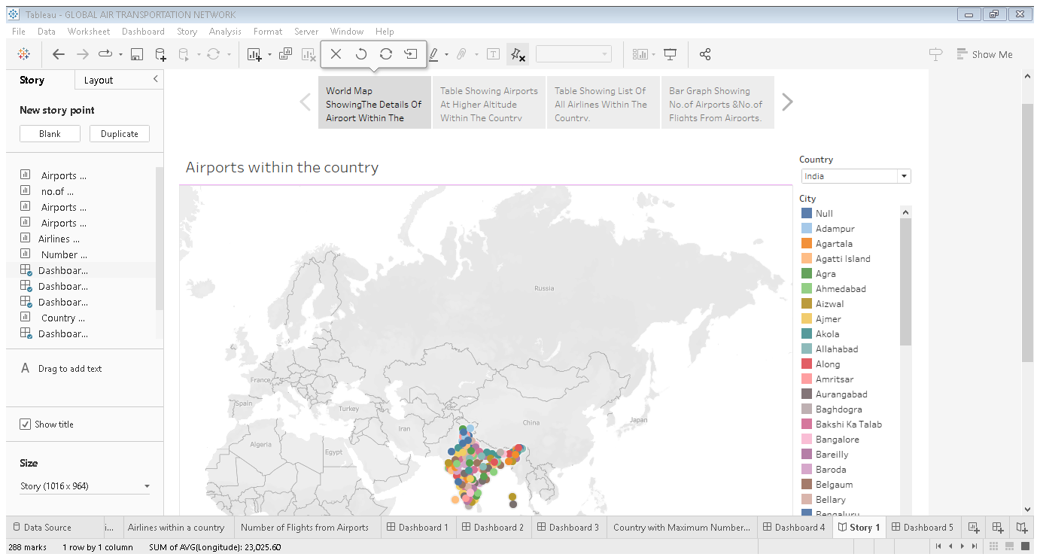

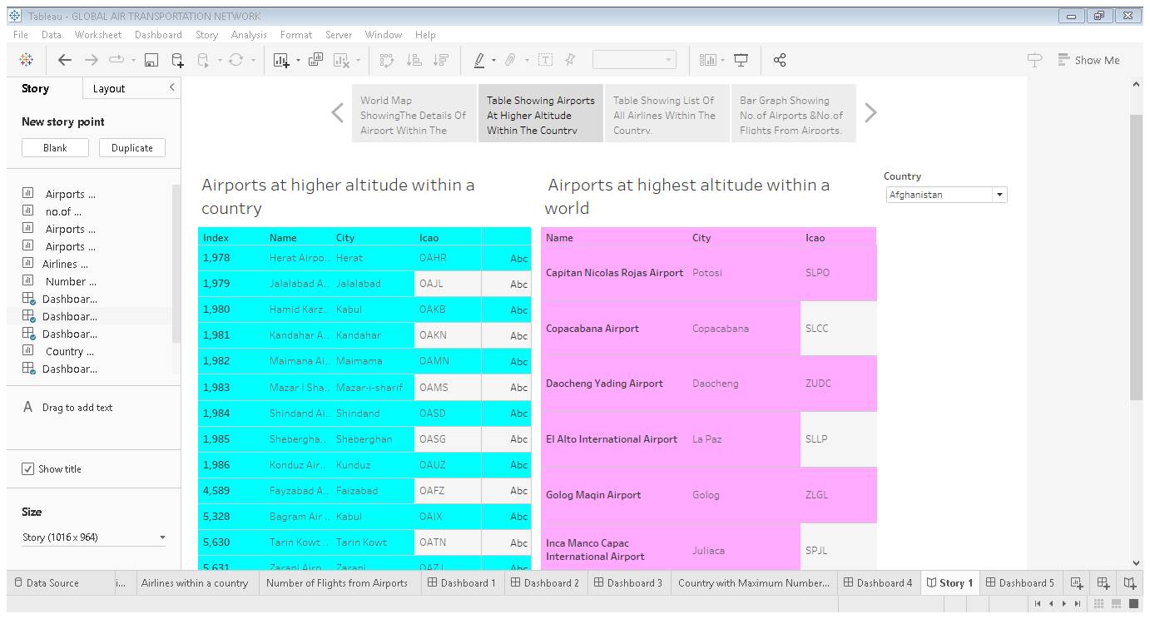

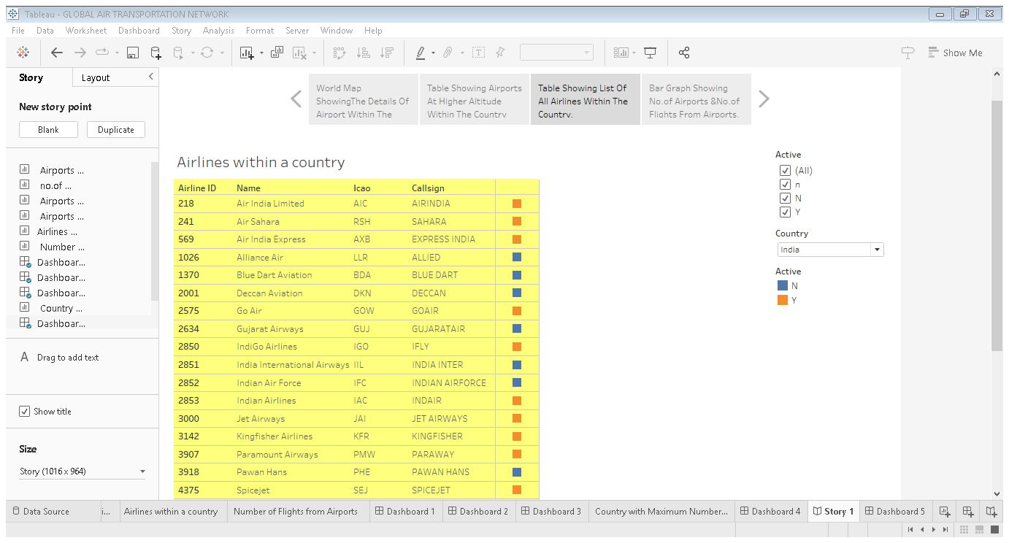

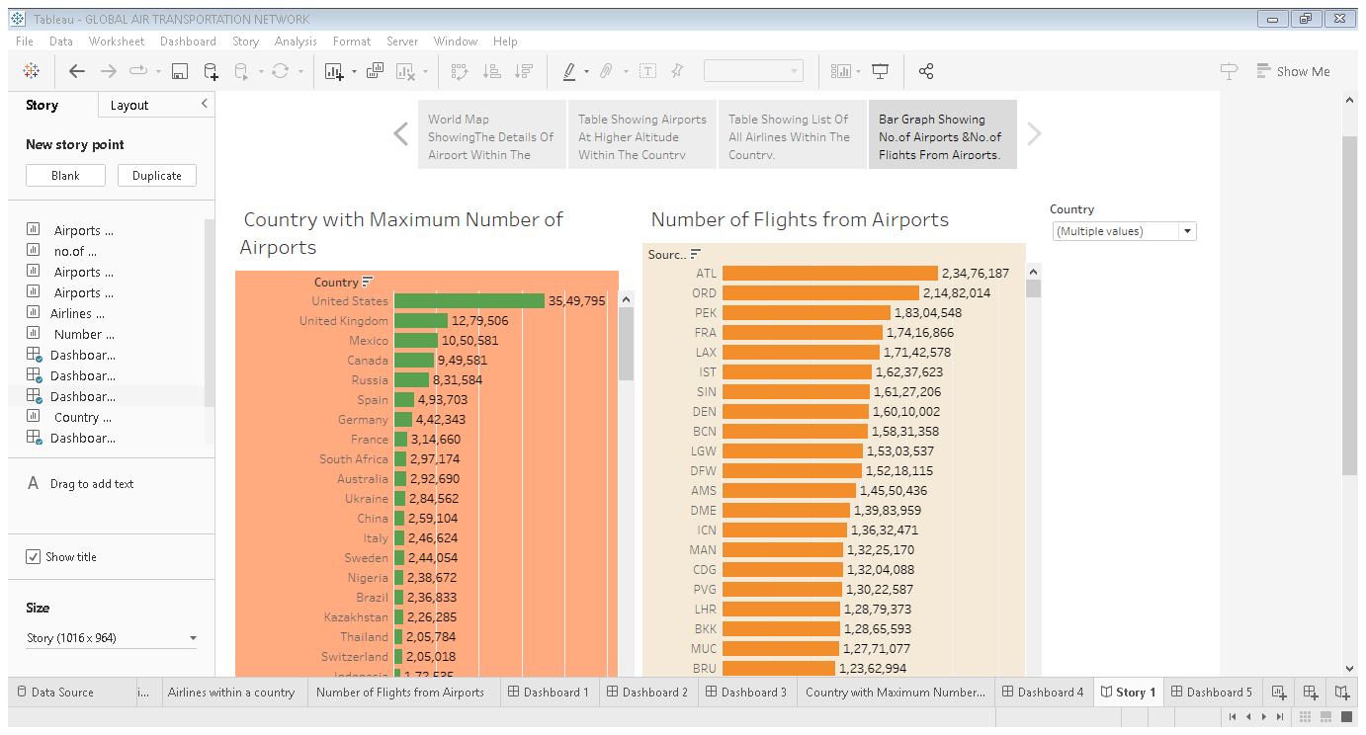

# *4.ADVANTAGES & DISADVANTAGES*

# Advantages:

* Fast speed
* Rapid service
* Low infrastructure
* No physical barriers
* Defence service
* Security

# Disadvantages:

* Costly service
* Limited capacity
* Huge investment
* Accident prone
* Requires skill
* Unfit for cheap

# *5.APPLICATION*

Used in all industrial sectors and distribution chains. Most companies use air transport to market goods and products internationally or to deliver samples and documents related to foreign trade operations.

# *6.CONCLUSION*

The international economy and the air transportation industry, in particular operate in a dynamic environment that is defined by long term megatrends and global challenges, such as population growth and the rise of mega cities, increasing demand for mobility in the context of increasing globalization, climate change and process of political transition.

# *7.FUTURE SCOPE*

The future of the aviation industry is likely to see continued growth and expansion, driven by factors such as a growing middle class, increased tourism and government policies supporting the industry.